**Marriage Products:**

# **1.Indian Decorations:**

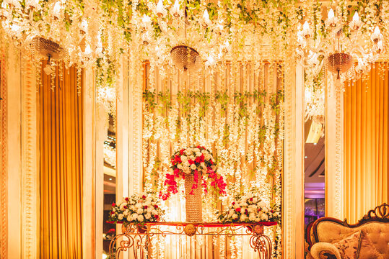**"At [Blooming Petal], we specialize in crafting mesmerizing Indian wedding flower decorations that reflect the essence of rich traditions and cultural heritage. With a deep understanding of the significance of flowers in Indian ceremonies, we curate exquisite floral arrangements that symbolize love, prosperity, and joy. Our dedicated team of skilled artisans and floral experts work closely with you to bring your vision to life, ensuring every detail aligns with your preferences and theme. From elegant mandap designs adorned with marigolds and jasmine to intricate floral garlands and centerpieces, our creations set the stage for unforgettable moments on your special day. We take pride in our commitment to delivering excellence, leaving you and your guests enchanted by the opulent and aromatic beauty of our Indian wedding flower decorations."**

# **2.Beach Design:**

**"Welcome to [Blooming Petal], your premier destination for enchanting beach wedding flower decorations. As experts in coastal celebrations, we specialize in creating captivating floral setups that blend seamlessly with the natural beauty of the shoreline. Our skilled team of designers and decorators meticulously craft dreamy beach-inspired arrangements, from stunning floral arches framing the ocean backdrop to whimsical seashell-adorned centerpieces. We strive to capture the essence of the beach, infusing every arrangement with a sense of serenity and romance. With an eye for detail and a commitment to perfection, we ensure that your beach wedding is a picturesque affair filled with the delicate allure of our floral masterpieces. Let us transform your special day into an unforgettable coastal paradise."**

# **3.Purrple Theme Decorations:**

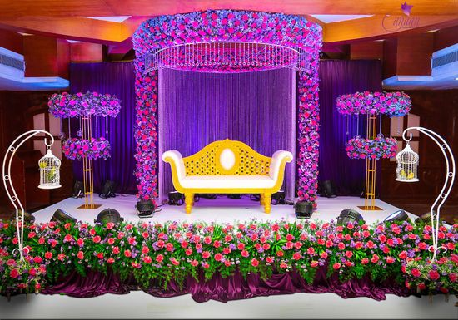**"Welcome to [Your Business Name], your premier destination for enchanting beach wedding flower decorations. As experts in coastal celebrations, we specialize in creating captivating floral setups that blend seamlessly with the natural beauty of the shoreline. Our skilled team of designers and decorators meticulously craft dreamy beach-inspired arrangements, from stunning floral arches framing the ocean backdrop to whimsical seashell-adorned centerpieces. We strive to capture the essence of the beach, infusing every arrangement with a sense of serenity and romance. With an eye for detail and a commitment to perfection, we ensure that your beach wedding is a picturesque affair filled with the delicate allure of our floral masterpieces. Let us transform your special day into an unforgettable coastal paradise."**

# **4.Pakistani Decorations:**

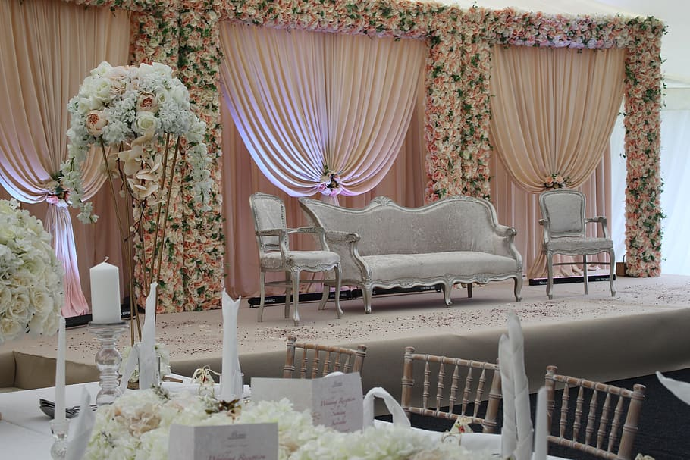**At [Your Business Name], we specialize in creating exquisite Pakistani wedding flower decorations that reflect the cultural richness and timeless elegance of Pakistan's traditions. Our skilled team of floral artisans and designers meticulously craft stunning setups, from intricately adorned stage backdrops to elaborately detailed entrance arches, all inspired by the vibrant colors and motifs of Pakistani culture. We understand the importance of incorporating traditional elements into your special day, and our personalized approach ensures that each arrangement complements your unique vision. With a keen eye for cultural authenticity and a commitment to quality, we aim to elevate your wedding celebrations, making them a harmonious blend of modern trends and timeless traditions. Let our floral masterpieces add a touch of opulence and grace to your cherished moments, creating memories that will last a lifetime.**

# **5.Engagment Decorations:**

**At [Blooming Petal], we take pride in offering a specialized engagement flower decoration service that sets the stage for a memorable and romantic celebration. With a keen understanding of the significance of this joyous occasion, we curate elegant and enchanting floral arrangements that capture the essence of love and commitment. Our expert team collaborates closely with you to bring your vision to life, transforming your engagement venue into a dreamlike setting filled with the beauty of fresh blooms. From captivating entrance decor to breathtaking centerpiece designs, every detail is thoughtfully crafted to reflect your unique style and preferences. Let us add a touch of floral magic to your engagement, creating an ambiance that leaves a lasting impression on you and your guests, and marks the beginning of a beautiful journey together.**

# **6.Italian Decorations:**

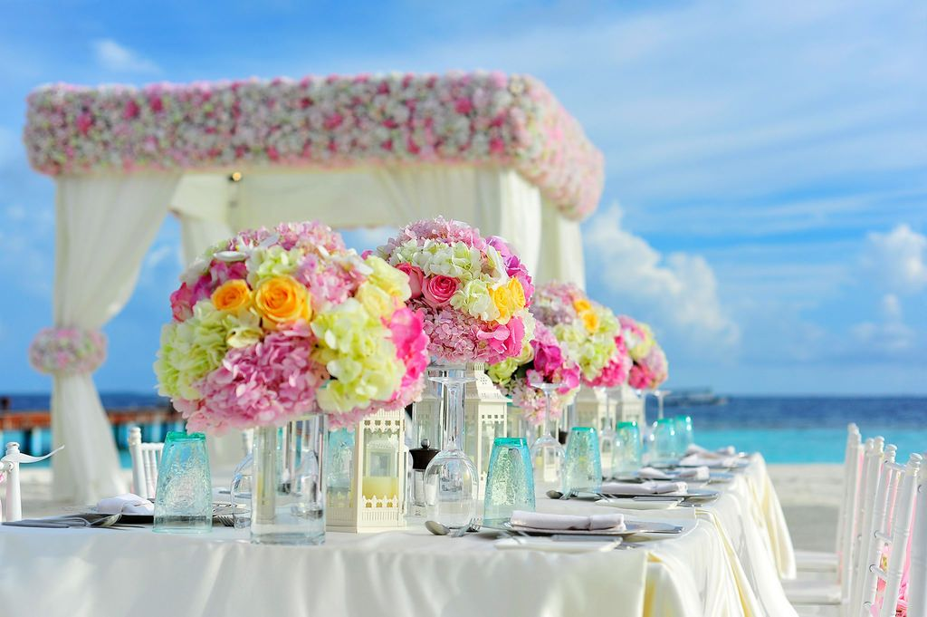**Welcome to [Blooming Petal], where we specialize in creating enchanting Italian wedding flower decorations that evoke the timeless charm and romance of Italy. Drawing inspiration from the picturesque landscapes and rich cultural heritage, our talented team of floral artisans designs exquisite arrangements that reflect the essence of la dolce vita. From elegant vineyard-inspired setups to classic Renaissance motifs, our creations transport you and your guests to an Italian dreamland. With a meticulous eye for detail and a passion for floral artistry, we curate captivating centerpieces, arches, and bouquets, elevating your special day to an unforgettable experience. Let us infuse your Italian wedding celebrations with the beauty and elegance of our floral masterpieces, leaving you with cherished memories of a truly magical affair.**